**Ideation Phase**

**Define the Problem Statements**

|  |  |
| --- | --- |
| Date | 19 September 2022 |
| Team ID | PNT2022TMID36144 |
| Project Name | Smart farmer - IOT Enabled Smart Farming Application |

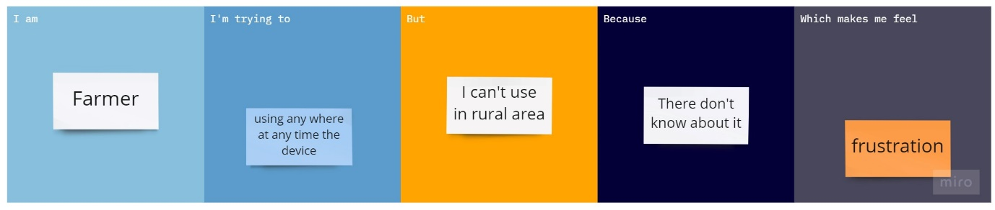

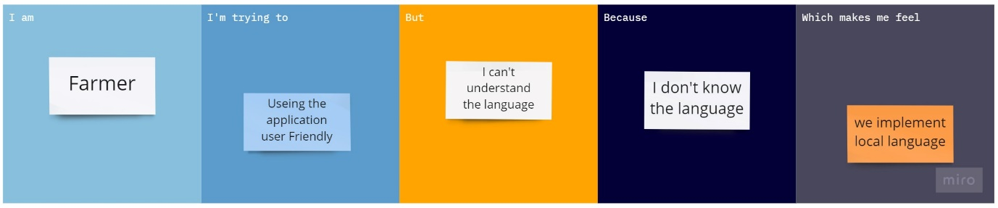

|  |  |  |  |  |  |
| --- | --- | --- | --- | --- | --- |
| **Problem Statement (PS)** | **I am (Customer)** | **I’m trying to** | **But** | **Because** | **Which makes me feel** |
| PS-1 | Farmer | Use this IOT device | I can’t | I don’t know how to use | Feel bad |
| PS-2 | Farmer | Use the application | It was hard | I don’t know the language | frustration |